Eight basic steps to become a iPhone developer:

- Buy a Mac
An Intel-based processor, running the Leopard version of MacOS X. Peter Scott, CTO at Connect2Media suggests Mac Minis, "they are more than powerful enough, small, easy on desk space when you already have PCs, three LCD monitors and a bunch of devices.
2. Down the SDK (software development kit)
"Apple provides the free SDK for iPhone development from their Developer site," explains Stuart Varrall, Creative Director at Fluid Pixel. "This includes everything you need to get going, including the development environment Xcode, the iPhone Simulator for testing, performance analysers, interface builders and the full documentation reference library."
3. Learn Objective C
This is the primary programming language for iPhone development. "It's an extension of C to include object-orientated principles," says Varrall. "It has scripting elements to it, so is easier to pick up than some languages and anyone with programming experience should be able to transfer their skills."
"Objective C was actually created by Next Computing owned by a certain Steven Jobs. When Jobs returned to Apple, he sold Next to the company and so Objective C became the main development environment for the Apple Mac. It is liked because in similar ways to Java, it deals with many of the problematic parts of programming…. It's nice, simple, hides the complexities of the hardware away from the developer and deals with (on the whole) the major cause of programming issues in C and C++ which is memory leaks."
"If you are proficient in C/C++ or Objective C then the learning curve is in getting to grips with the APIs of the iPhone - the best place to start is the iPhone developer site. If you need to learn the programming languages themselves then the best place to start is a beginners book, actually the For Dummies series is very good for this. Also look at one of the many free tutorials online - Googleing 'objective C tutorial' throws up many places to get these."
The official Apple SDK has a wealth of detail along with examples of implementing various features. The Apple developer forum is rapidly growing to be the best place for specific questions or to get further clarification on something.
4. Start writing something!
Forget theory; forget mastering Objective C with your first attempt. Just set yourself a project and start working. "I knew nothing about Objective C, Cocoa, or OpenGL prior to starting iShoot. In fact I barely even knew C," admits Ethan Nicholas. "I hadn't really touched it in a decade. I was a Java programmer for twelve years and it was quite an adjustment moving from a nice safe language like Java to one where a single misplaced byte can instantly crash your program."
Nicholas' first aim – and this is more or less standard procedure in the development community when presented with a new platform – was to get something to appear on the screen. "The first thing I worked on was the ground. I wanted to create a destructible landscape with falling dirt. Since I had no idea how to load textures at that point, and had just grasped the basics of Objective C and OpenGL, my dirt "texture" was just solid white. So the first thing I got onscreen was just a white rectangle that represented the ground
"By day two, my featureless white rectangle had morphed into a properly textured landscape and most of the dirt-descruction code was working. By the end of the first week I had a tank on the screen firing shots randomly, blowing holes in the ground. When I finally got it on to an actual phone and not just the simulator, I found that it only ran at one frame per second, so I had some considerable optimisation work ahead of me."
If you can't face starting out on an original project, however, Varrall suggests a couple of modification tasks. "The SDK actually comes with a whole host of sample projects that cover most aspects of development. So the best place to start would be to take one of those and reverse engineer it and work out how it has been constructed. You can then build on these by adding new features and create your very own game very quickly."
5. Sign-up as an official developer
If you plan on releasing your masterpiece at any point, you'll need to sign up with the iPhone Developer Program. The Standard cost is $99, and it involves agreeing to Apple's terms and conditions, and signing and returning the contract. Even if you're nowhere near completing the project, you'll need to sign up in order to test your code on an actual iPhone rather than an onscreen emulator. Once you're on the Developer Program you're sent a certficate, which allows you to pair up with an iPhone device.
6. Prepare for a few weeks of work…
Depending on the time available, and your level of programming knowledge, developing an iPhone game can mean as little as a couple of months' work. "Including learning Objective C, Cocoa, and OpenGL, I spent exactly six weeks on iShoot," says Nicholas. "The hardest part was adjusting to an unsafe language... after twelve years working in Java, it's very difficult to get back into the proper mindset for debugging crashes. I had one memory corruption issue where it turned out that literally only a single byte was being corrupted, and it didn't cause the program to crash until several minutes after the corruption occurred. It took me three days to find that one…"
KamiCrazy: six weeks to develop with a team of five...
The professional studios I spoke to provided similar timeframes, though they involved teams rather than lone coders. "KamiCrazy took three months to develop part-time, so could be done in a month full-time," reckons Varrall, who used three programmers, one artist and a producer. "The programming was focussed on the most part into making the robust engine that drives the game and included the level editor, allowing the levels to implemented with ease. This means that this technology can be re-used and future titles could be turned around in less time. The art took three weeks in total to produce."
7. Submit your app to Apple
Okay, this is the big one. "Finished games have to be submitted to the App Store using the same interface as music producers use," explains Varrall. "It's a straightforward process of zipping up the file, uploading it with a description, a large and small icon, and screenshots. If everything is alright then it usually takes Apple a week to approve the content and it finds itself in the store. If there is a problem, such as obvious bugs or Lite apps that are mentioned as demos or aren't fully featured, then this can take longer to review and ultimately reject. In this instance you can fix the issue and resubmit as many times as you like."
"Any iPhone developer will tell you that the provisioning and code signing is a pain, but once I had that sorted out the submission process was trivial," agrees Nicholas. "Fill in the fields, wait a few days, eagerly anticipate your first sales report... and then watch everybody completely ignore your app as you sell fewer than 20 copies a day. iShoot wasn't exactly a resounding success in the beginning…"
8. Adapt, market and survive!
The work doesn't finish once you've made it onto App Store. As it's unlikely you'll have your own in-house QA department, some bugs and design issues may only surface when hundreds of gamers get their hands on the code. Consequently, it may be necessary to submit several alterations.
And as Nicholas mentioned, don't expect an immediate response to the release – App Store is an open market, featuring around 20,000 applications and 2,000 games. To get noticed, you'll need to build a buzz around the game: engage with the development and gaming communities, start a blog about the programming process, produce screenshots and mail out press releases to iPhone news sites like Pocket Gamer, Touch Arcade and FingerGaming. And, of course, utilise social networking sites like Twitter, Facebook and Bebo.
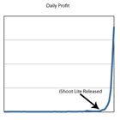The iShoot profit graph: releasing the Lite version had a reasonably dramatic effect on sales of the original...
Or just produce a free demo version. iShoot was widely ignored for several weeks before Nicholas decided to produce a cut-down 'Lite' version which he made available for free. "it quickly became the #1 free application, and iShoot sales followed suit. Here is an actual graph of my daily sales from iShoot's launch through to when it became number one. To put things in perspective, you see the biggest spike before iShoot Lite was released? That tiny little bump? That was Christmas Day, when I made over $500 in a single day. I was quite excited about that at the time."
While at the top of the Paid Apps chart, iShoot was getting over 10,000 downloads a day, at $2.99 each. Take out Apple's standard 30% commission and Nicholas was pulling in $21,000 a day. He quit his job at Sun and is now working on a new game ("My next project involves airborne sheep, but I'm afraid that's all I can share at the moment"). You could be next….
http://www.guardian.co.uk/technology/gamesblog/2009/feb/10/gameculture-apple

Publishing Applications for Testing

After testing and tuning your application yourself or with the assistance of your teammates, it’s always a good idea to perform wider testing with a representative sample of your application’s potential users. Such testing may reveal issues that surface only with particular usage patterns. Incorporating a few nondeveloper users in your testing strategy lets you expose your application to a variety of usage styles, and, if such usage produces crashes in your application, allows you to collect the crash reports (also known as crash logs) from those users to help you resolve those execution problems.
An iPhone application in development can run only on devices with provisioning profiles generated by the application developer. As iPhone Developer Program members, you and your fellow team members install these files on your devices as part of your development process. To include users that are not part of your team (also known as testers) in your testing strategy, you must add them as part of your team in the Program Portal and issue them test provisioning profiles (also known as ad-hoc provisioning profiles), which allow them to install on their devices applications that have not been published to the App Store.
Figure illustrates the process of adding users as testers and delivering your test application to them.
Figure Adding testers to your team
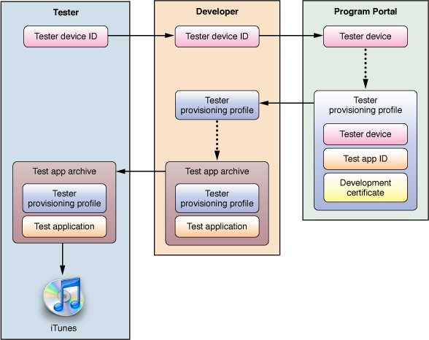
To help testers obtain the information you need to add them to your testing program and to show them how to send you crash logs, you can send them the information in “Instructions for Application Testers.”
Important: To add testers to your team, you must be a member of the iPhone Developer Program. See “Managing Devices” for details.
The remainder of this chapter describes the steps you need to perform to add testers to your team and shows how to add symbol information to their crash logs, also known as symbolicating.
Prerequisites: Before publishing your application for testing, review the information in “Running Applications.”

Adding Testers to Your Team
To add an iPhone OS user to your team as a tester:
- Obtain the tester’s device ID.
The easiest way to obtain this information is through email. Have your tester follow the instructions for sending their device ID to developers in “Sending Your Device ID to Developers.”
- Add the tester’s device ID to the Program Portal.
- Generate the tester’s provisioning profile in the Program Portal.
You must select a development certificate, application ID, and only the tester’s device name.

Adding the iTunes Artwork to Your Application
Test versions of your application should contain artwork iTunes uses to identify your application. Otherwise, when users add your application to their iTunes library, iTunes uses generic artwork for it, as shown in Figure.
Generic iTunes artwork for test applications
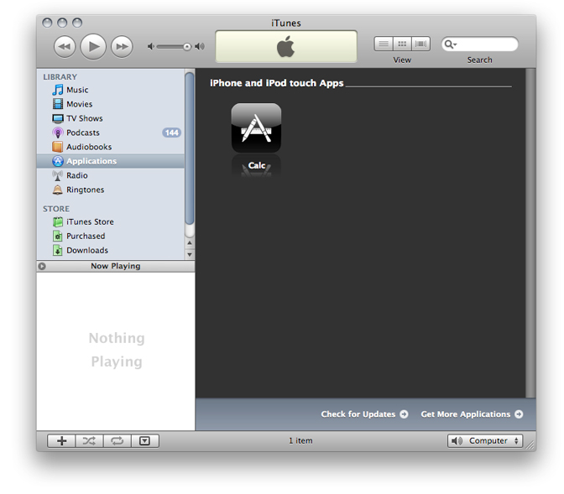
The iTunes artwork your testers see should be your application’s icon. This artwork must be a 512 x 512 JPEG or PNG file named iTunesArtwork. Note that the file must not have an extension.
After generating the file of your application’s icon, follow these steps to add it to your application:
- Open your project in Xcode.
- In the Groups & Files list, select the Resources group.
- Choose Project > Add to Project, navigate to your iTunesArtwork file, and click Add.
- In the dialog that appears, select the ”Copy items” option and click Add.

Distributing Your Application to Testers
Before sending your application to a tester build it using the Release build configuration. You can find the directory containing your binary (and its corresponding dSYM file) by choosing Reveal in Finder from the application in the Products group in the Groups & Files list.
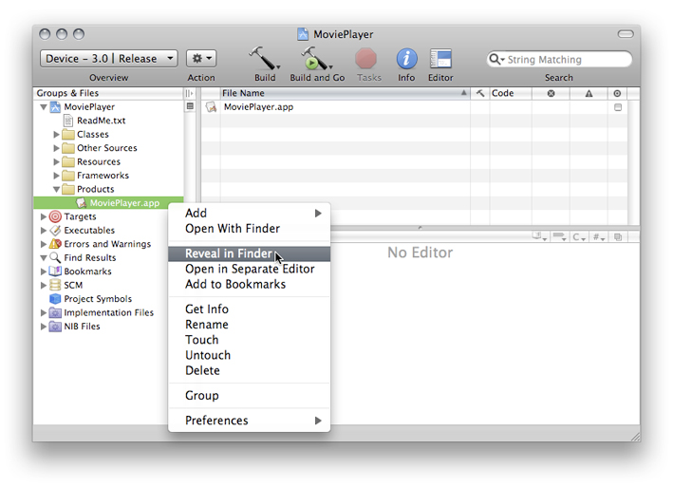
Remember to keep the binary and its corresponding dSYM file on your file system (copy them to a directory that contains a subdirectory for each build you’ve released to your teammates or to testers) so that they’re indexed by Spotlight.
Send your application binary and the tester’s provisioning profile to the tester. One way of accomplishing this task is by compressing these items and emailing them to the tester:
- In the Finder, select the two files and choose File > Compress.
- Name the archive <application_name> for <user_name>.zip. For example, MyTestApp for Anna Haro.zip.
- In the Finder, select the archive and choose Finder > Services > Mail > Send File.
- In the body of the message make sure to include your application’s target iPhone OS release. If the tester’s iPhone OS version is earlier than the one for which your application was built, they will not be able to install the application on their device.
http://developer.apple.com/iphone/library/documentation/Xcode/Conceptual/iphone_development/145-Publishing_Applications_for_Testing/user_testing.html#//apple_ref/doc/uid/TP40007959-CH10-SW2
Apple mailing lists:
A mailing list is an e-mail based discussion group. Sending one e-mail message to the mailing list's address sends mail to all other members of the group. Users join a mailing list by subscribing and subscribers to a mailing list receive messages from all other members. Users have to unsubscribe from a mailing list to stop receiving messages forwarded from the group's members.
http://lists.apple.com/faq/index.php?sid=130658&aktion=artikel&rubrik=002&id=48&lang=en

THE WWDC Experience:
The Apple Worldwide Developers Conference (WWDC) is the premier technical event for developers and IT professionals innovating with Apple platforms. Over 1,000 Apple engineers will be at Moscone West to present the latest Apple technologies and provide you with code-level guidance. You’ll learn how to harness the power of iPhone OS, Mac OS X Snow Leopard, and Mac OS X Server Snow Leopard in the most efficient and sophisticated way possible — saving you time and accelerating your development. Bring your MacBook and your imagination, and prepare to make your ideas happen.
http://developer.apple.com/WWDC/
Apple Developer Connection:
Apple does not provide online support to Developers in Apple Discussions.
Apple Discussions Community members are welcome to assist each other.
The Apple Developer Connection for developer support options.
http://developer.apple.com/

Apple Developer Forums Beta
Post iPhone SDK development topics and questions for an open discussion with other iPhone developers and Apple engineers.

Technical Support
The iPhone Developer Program includes two Technical Support Incidents where Apple engineers will provide you with code-level assistance, helpful guidance, or point you towards the appropriate technical documentation to fastrack your development process.
http://developer.apple.com/iphone/program/test.html
Distribution of the application:
The iPhone Developer Standard Program provides you access to the App Store where you can distribute your free or commercial application to millions of iPhone and iPod touch customers. The iPhone Developer Enterprise Program is for companies that are looking to deploy their proprietary in-house applications using their Intranet.

App Store
Reach millions of iPhone and iPod touch customers on the App Store.
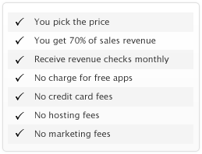
The App Store is accessible through Wi-Fi and cellular networks so iPhone and iPod touch customers can discover and download new applications wherever they go. Users can search applications by genre, featured, and top ten. Once downloaded, customers will be notified whenever an update is available - directly on their iPhone or iPod touch.

Enterprise Distribution
For deploying proprietary in-house applications to authorized users in your company, the iPhone Developer Enterprise Program is available to companies with 500 or more employees.

Ad Hoc Distribution
The Standard and Enterprise Programs allow you to share your application with up to 100 other iPhone or iPod touch users with Ad Hoc distribution. Share your application through email or by posting it to a web site or server.
http://developer.apple.com/iphone/program/distribute.html
List of apps rejected by the app store:
Here’s a brief and not-at-all exhaustive list of apps that have been banned, held up or changed because of Apple’s App Store rules:
- Eucalyptus – This e-book reader was rejected because it let users read the Kama Sutra, from Project Gutenberg. Apple decided this was “inappropriate content,” even though the book could easily be read from several other applications on the store, including Amazon’s Kindle app. After extensive media coverage, Apple relented and allowed the app in.
- NetShare – Apple initially approved this app, which allows users to browse the Internet on their computer through the iPhone’s data connection, but then proceeded to ban it once it got some media attention. Typically, AT&T sells data “tethering” for $60 a month. No tethering apps allowed.
- Baby Shaker – Some developers are left scratching their heads trying to figure out why their apps got denied, when others get through without an issue. Baby Shaker simulated shaking a baby to death with the accelerometer. Apple quickly pulled the app, but it begs the question: How did this get through the approval process?
- Perfect Acumen – Sure, Apple might have more 50,000 apps on the store, but 943 of them were from these folks. The developer posted tons of one-subject apps that were little more than glorified RSS readers dedicated to one or two subjects. Economic Crisis Updates, iSoaperStarsUpdates, Top Sexy Women, and more. The apps are all $4.99 and likely cost next to nothing to make. Even if the company only sold a few of each item, it’s still a likely profitable business “model” — or it was, until Apple banned the entire company, apps and all, from the store.
- Google Voice – Apple’s rejection of the Google Voice application, perhaps the most famous App Store rejection, got the FCC’s attention. The commission sent letters to Apple, Google and AT&T to determine how and why the application was rejected from the App Store and if the iPhone maker’s actions were anti-competititve. This story is a long, long way from over. It’s unclear if Google CEO Eric Schmidt’s resignation from the Apple board had anything to do with this, but it can’t have helped.
- Nine Inch Nails – Trent Reznor submitted a Nine Inch Nails app to the store, but it was denied because of “objectionable content” — in this case, a NIN song titled “The Downward Spiral” that was included in the app. Reznor was furious with Apple because the same song is available, unedited, on the iTunes Music Store. Apple later relented and posted the app.
- Opera – The Norwegian browser maker, very popular on a number of mobile platforms, designed a version of Opera Mini for the iPhone, but it was rejected because it competes with Apple’s Safari browser and includes a separate JavaScript interpreter — a big no-no for developers.
- “South Park” – Trey Parker and Matt Stone, the guys behind “South Park,” made an iPhone app for their TV show, but “after a couple of attempts to get the [app] approved,” the program was rejected for “potentially offensive” content. In an announcement about the rejection, “South Park” claimed Apple admitted its “standards would evolve,” noting that when iTunes was first launched, there was no music available with explicit lyrics. For now, though, it’s the iPhone that killed Kenny.
- Pull My Finger – Apple originally rejected the Pull My Finger app because it was “of limited utility” to the community — however, after much deliberation, Apple decided to accept the app. The company noted that it’s “still determining how this new genre of [humor] apps would be handled.” Once it was approved, though, the iPhone community resoundingly voted with their wallets, sending the fart-noise app up the best-seller list. The App Store’s fart apps even made it onto “The Daily Show.”
- FreedomTime – This app, released last fall, counted down the days until then-President George W. Bush left office. Apple denied the app because it was potentially defamatory or demeaning to a national figure. That may be true, but still, why deny the app? It’s not as bad as some others. The developer even emailed Apple CEO Steve Jobs about the rejection — and received a response! Jobs replied, “Even though my personal political leanings are Democratic, I think this app will be offensive to roughly half our customers. What’s the point?” What’s the point indeed, Mr. Jobs — what’s the point of rejecting this app?
http://gigaom.com/2009/08/04/the-great-firewall-of-apples-app-store/

